



IN553 Database Systems

Accrington and Rossendale College

Bucks New University

Student ID: 20140842

Bucks Student ID: 21402984

Contents

Summary of the Database 3

Entity Relationship Diagram 4

Data Dictionary 5

Queries + SQL 8

Testing 15

# Summary of the Database

In this assignment, the database will be outlined in the scenario (shown below) and will display the criteria, structure of the database and all queries that will be required to run the search criteria for specific information within the database.   
 The database scenario chosen for this project was an adaption of the NFL (American National Football League). The tables within the database are listed as ‘League’, ‘Player’, ‘Results’, ‘Fixtures’, ‘Player Results’ and ‘Teams’. In the database, there is a League table to show the position of each team so that the user can see where their favourite team is in the league and how many points they have accumulated so far over the current season.   
 There is also a Player table to enable the user to see how well the star player of the week has performed in each team and how many points they have gained throughout the season.   
 The Results table allows the user to see the results of the latest weekly game, the teams that have played and the score recorded from each game of that week. Linking this to the Fixtures table, the user will be able to see the upcoming fixtures, venues and dates over the next four weeks. This will allow the user plenty of time to buy tickets or enable them to watch it through their devices at home. The Player Results table shows how well each star player has performed from the winning team and how many points they have collected from the past game depending on their performance. At the end of the season an overall winning team will be declared as well as an overall star player. All this information is constantly updated throughout the season until the end where a winning team is declared. The final table is a Teams table, this able allows the user to see which teams are in the league this year and which position they currently hold. This table will be updated every season allowing the user to add and remove teams depending on their position at the end of the season.

# Entity Relationship Diagram

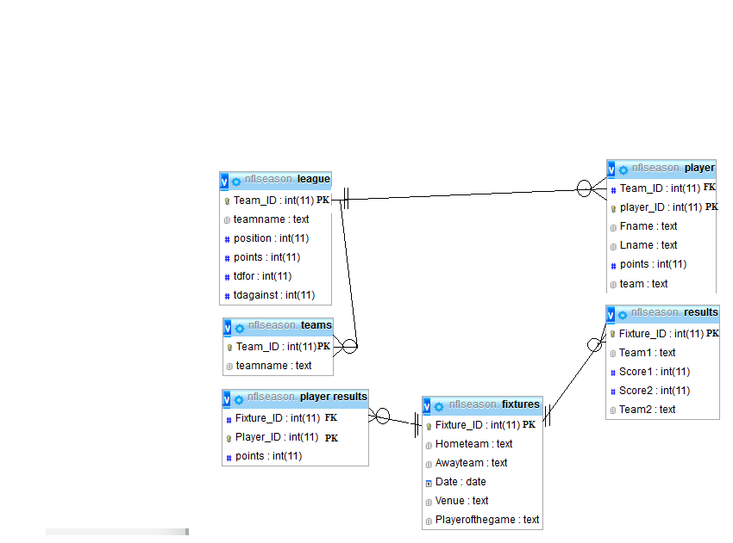

# Data Dictionary

League

|  |  |  |  |  |  |  |
| --- | --- | --- | --- | --- | --- | --- |
| Column | Data Type | PK | NN | UN | AI | Description |
| Team_ID | Int | V | NN |  | V | Team ID automatically generated |
| TeamName | Text |  | NN | UN |  | Name of the teams |
| Position | Int |  | NN |  |  | Position of the teams |
| Points | Int |  | NN |  |  | The amount of points each team accumulates |
| TD For | Int |  | NN |  |  | The amount of touchdowns scored |
| TD Against | Int |  | NN |  |  | The amount of touchdowns conceded |

Player

|  |  |  |  |  |  |  |
| --- | --- | --- | --- | --- | --- | --- |
| Column | Data Type | PK | NN | UN | AI | Description |
| Team_ID | Int |  | NN |  | V | Identity of team |
| Player_ID | Int | V | NN |  | V | Identity of player |
| FName | Text |  | NN | UN |  | First name of player |
| LName | Text |  | NN | UN |  | Last name of player |
| Points | Int |  | NN |  |  | Points player has accumulated so far |
| Team | Text |  | NN |  |  | Team the player plays for |

Results

|  |  |  |  |  |  |  |
| --- | --- | --- | --- | --- | --- | --- |
| Column | Data Type | PK | NN | UN | AI | Description |
| Fixture_ID | Int |  | NN |  | V | ID number of the game |
| Team1 | Text |  | NN | UN |  | Displays first Team |
| Score1 | Int |  | NN |  |  | Displays first score |
| Score2 | Int |  | NN |  |  | Displays second score |
| Team2 | Text |  | NN | UN |  | Displays second team |

Fixtures

|  |  |  |  |  |  |  |
| --- | --- | --- | --- | --- | --- | --- |
| Column | Data Type | PK | NN | UN | AI | Description |
| Fixture_ID | Int | PK | NN |  | V | Displays ID number of the game |
| Team1 | Text |  | NN | UN |  | Displays team A |
| Team2 | Text |  | NN | UN |  | Displays team B |
| Date | Date |  | NN |  |  | Shows the date of the next game |
| Venue | Text |  | NN | UN |  | Shows where the next game will be played |
| Playerofthegame | Text |  | NN | UN |  | Displays the top performing player of the game |

Player Results

|  |  |  |  |  |  |  |
| --- | --- | --- | --- | --- | --- | --- |
| Column | Data Type | PK | NN | UN | AI | Description |
| Fixture_ID | Int |  | NN |  | V | Displays ID number of the game |
| Player_ID | Int | V | NN |  | V | Displays ID of the Star player of that game |
| Points | Int |  | NN |  |  | Displays the points the player gained in that game |

Teams

|  |  |  |  |  |  |  |
| --- | --- | --- | --- | --- | --- | --- |
| Column | Data Type | PK | NN | UN | AI | Description |
| Team_ID | Int | V | NN |  | V | ID of the team |
| Teamname | Text |  | NN | UN |  | Name of the team |

# Queries + SQL

1. League Positions  
   Display both teams and positions of the teams in the league, with their team ID.  
   Information required from the ‘league’ table.  
   Select team_ID, teamname, position  
   From league;  
   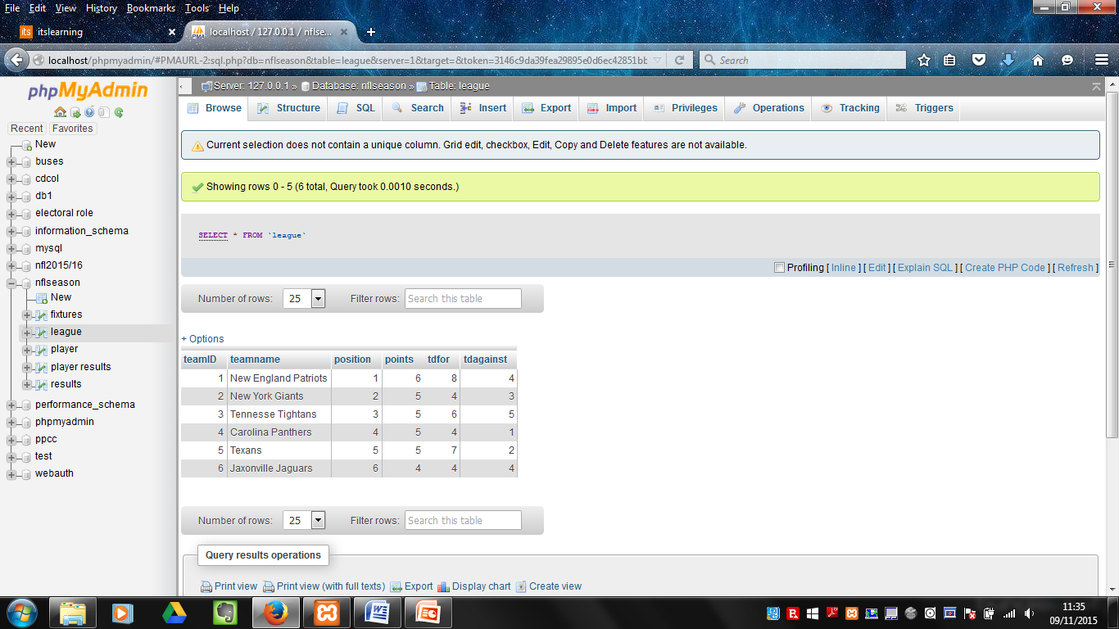
2. Player Points  
   Show the points each player has scored for their team this week.  
   Information required from the ‘player’ table.  
   Select Lname, points, team  
   From player;  
   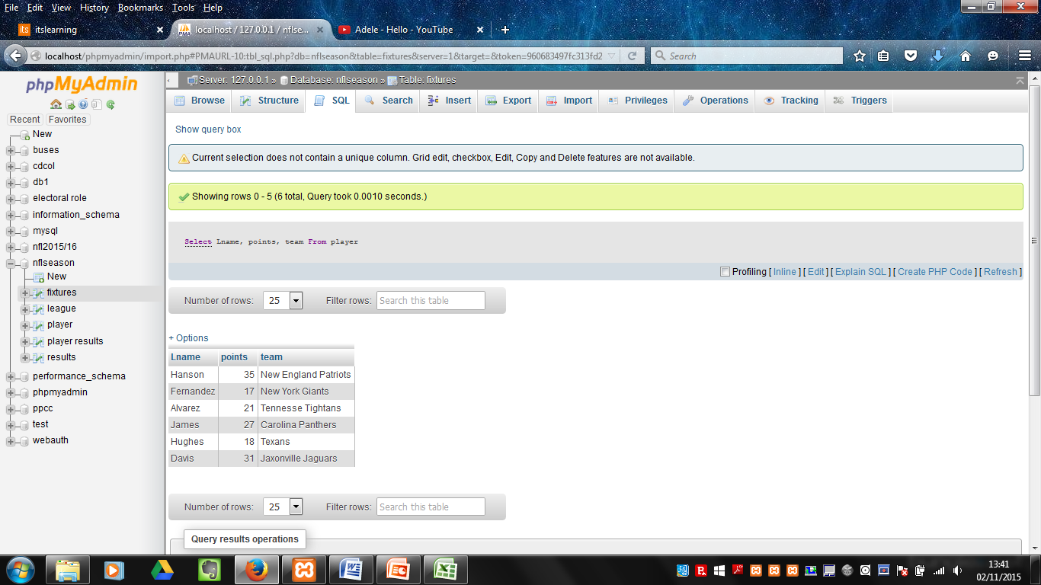
3. Winning Teams  
   Display the score and winning team from the Results table.  
   Information taken from the ‘results’ table.  
   Select GameID, Team1, Score1, Score 2  
   From Results;  
   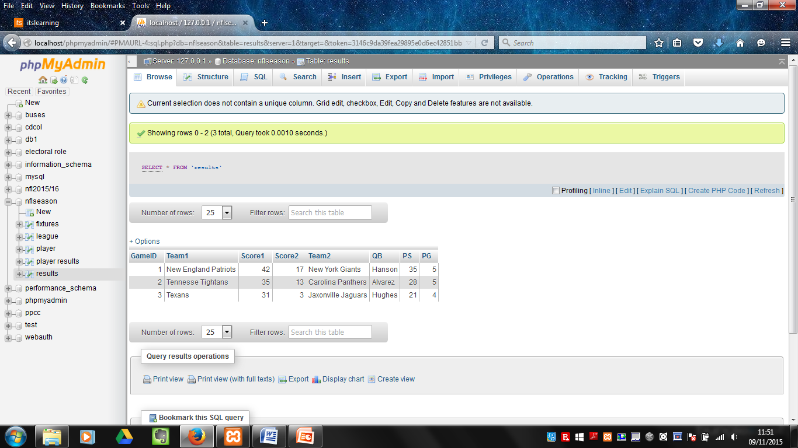
4. Fixtures and Venue’s  
   Display the game ID, dates and venues of each game from the fixtures table.  
   Information taken from the ‘fixtures’ table.  
   Select Description, Date, Venue  
   From fixtures;  
   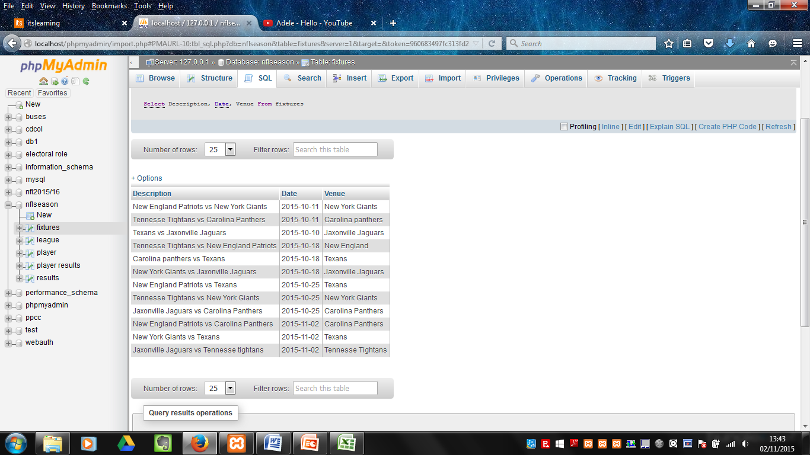
5. Teams who have 5PTS or more  
   Show all teams in the league who have scored more than 5 points.  
   Information taken from the ‘league’ table.  
   Select teamname  
   From league  
   Where points >= 5;   
   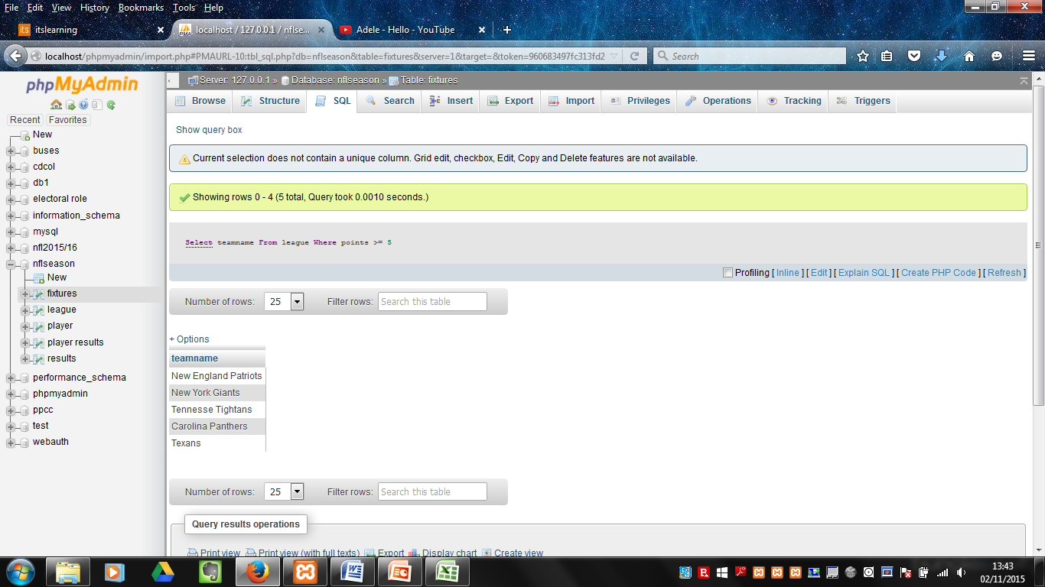
6. Players with more than 25 points  
   Show all players who have scored more than 25 points so far.  
   Information taken from the ‘player’ table.  
   Select Lname  
   From player  
   Where points > 25;  
   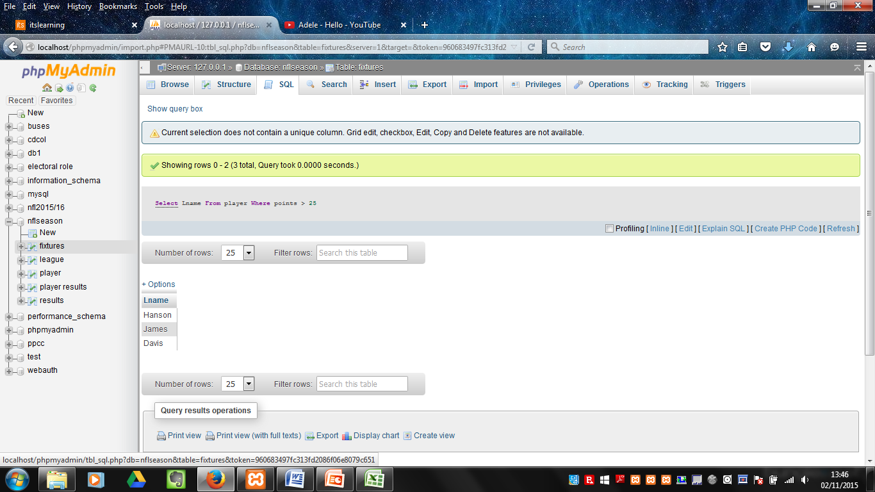
7. Teams with 5+ points/ touchdowns  
   Show all teams who have gained 5 or more points or have more than 5 touchdowns.  
   Information taken from the ‘league’ table.  
   Select teamname  
   From league   
   Where points >= 5 OR tdfor > 5;  
     
   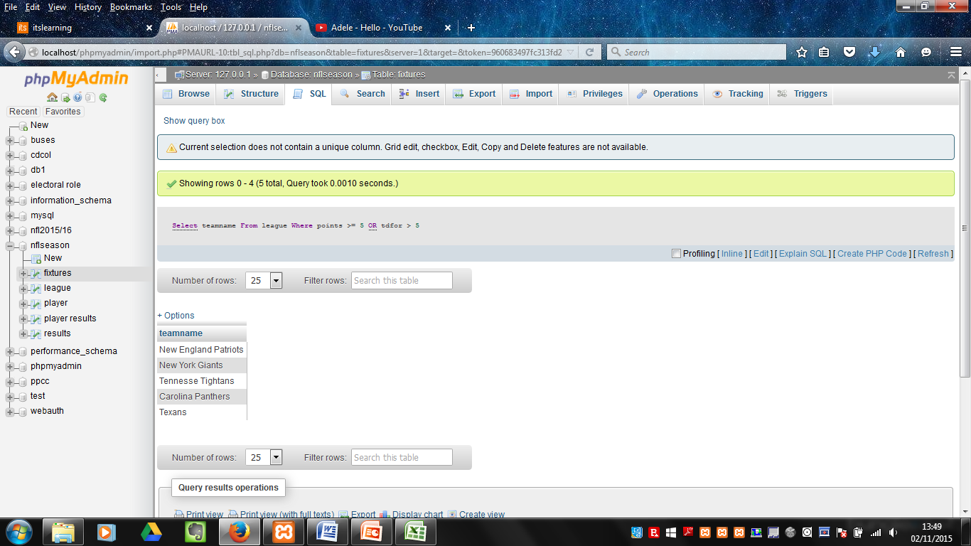
8. Teams with 5+ points and 3+ tdagainst  
   Show all teams who have scored 5 or more points and have conceded more than 3 touchdowns.  
   Information taken from the ‘league’ table.  
   Select teamname  
   From league  
   Where points >= 5 AND tdagainst > 3;

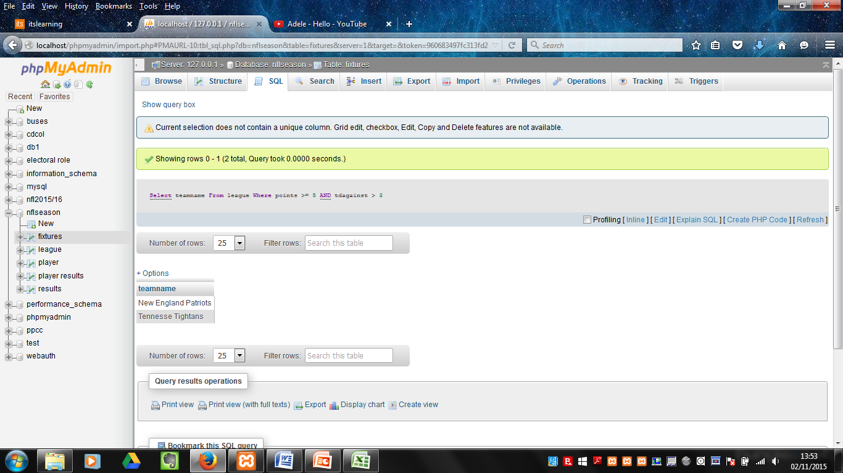

1. Teams with 4+ points and 4+ tdfor or 4- tdagainst   
   Display all teams in the league who have scored more than 4 points and have scored more than four touchdowns or have conceded less than 5 touchdowns.   
   Information taken from the ‘league’ table.  
   Select teamname  
   From league  
   Where points >= 4 AND tdfor > 4 OR tdagainst <5  
   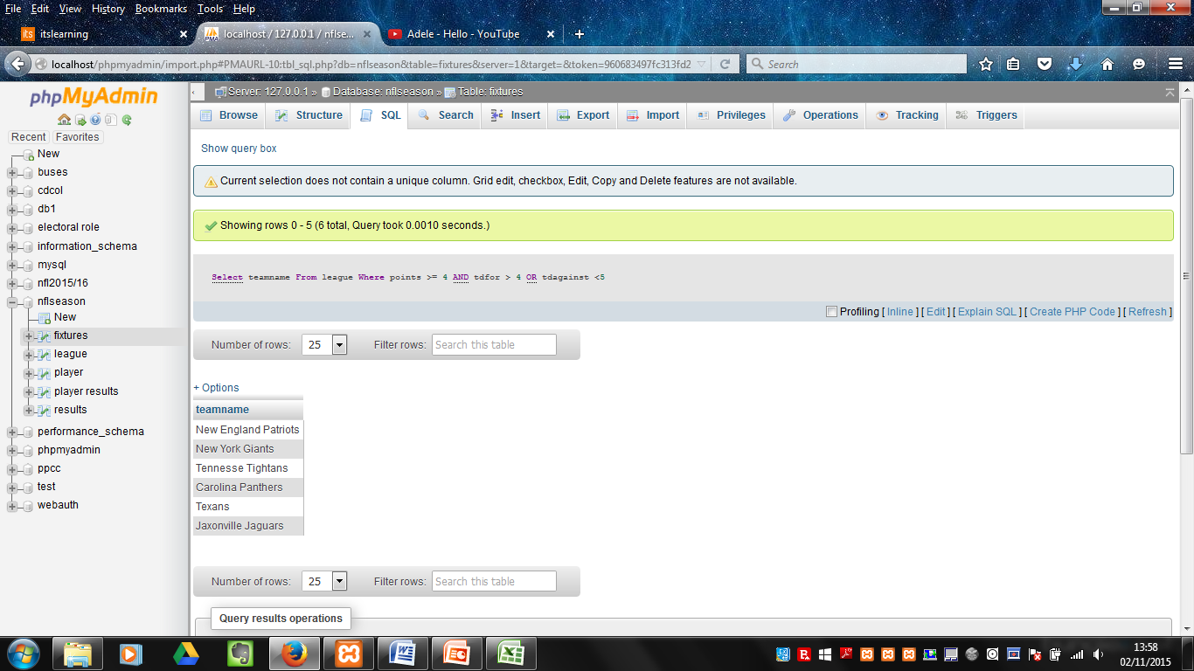
2. Texan dates and venue’s  
   Display all the games being played from the fixtures table where the Texans host the match after the 11 of October 2015 or show all matches hosted by the Texans displaying all Result ID’s greater than 5.   
   Information taken from the ‘fixtures’ table.   
   Select Description  
   From fixtures  
   Where Venue = ‘Texans’ AND (Date > 2015-10-11 OR Result_ID >= 5);  
   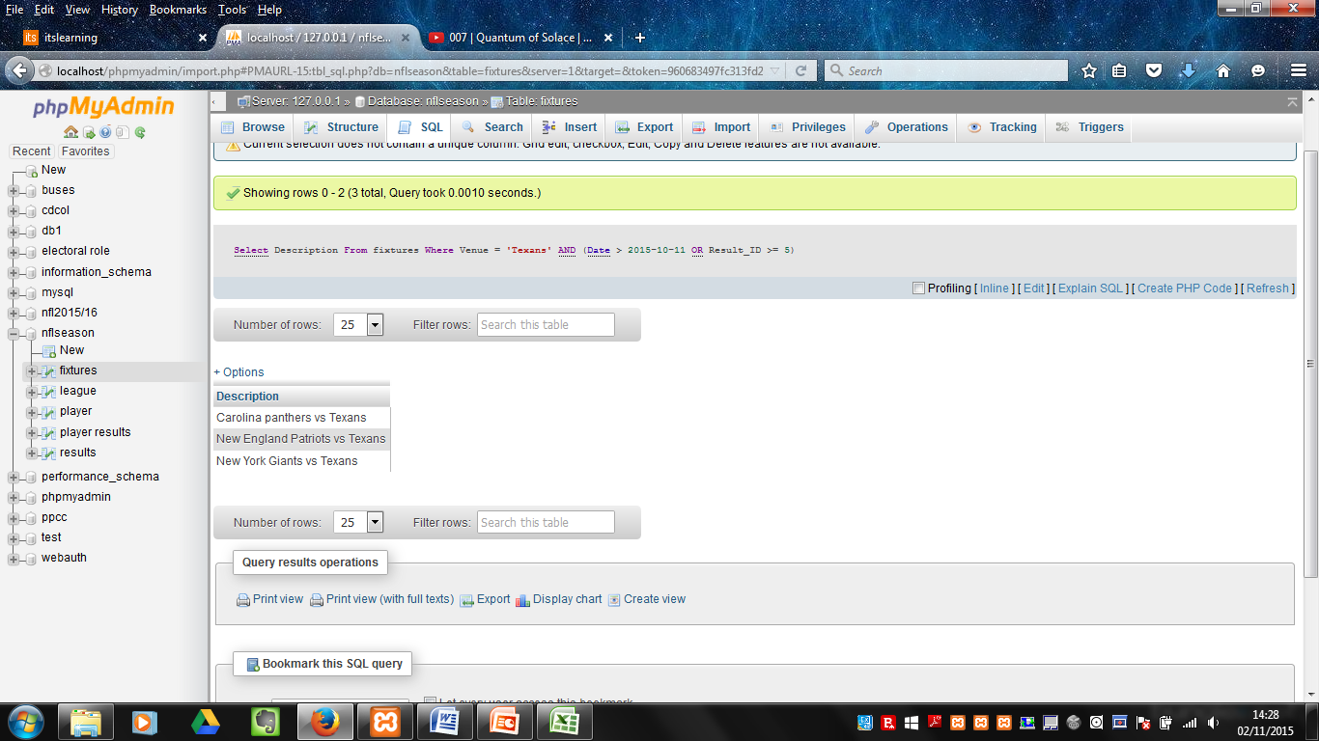
3. Last names beginning with ‘H’  
   Display all player ID’s who’s last names start with ‘H’.  
   Information taken from the ‘player’ table.  
   SELECT player_ID , Fname, Lname  
   From player  
   WHERE Lname LIKE ‘H%’;  
   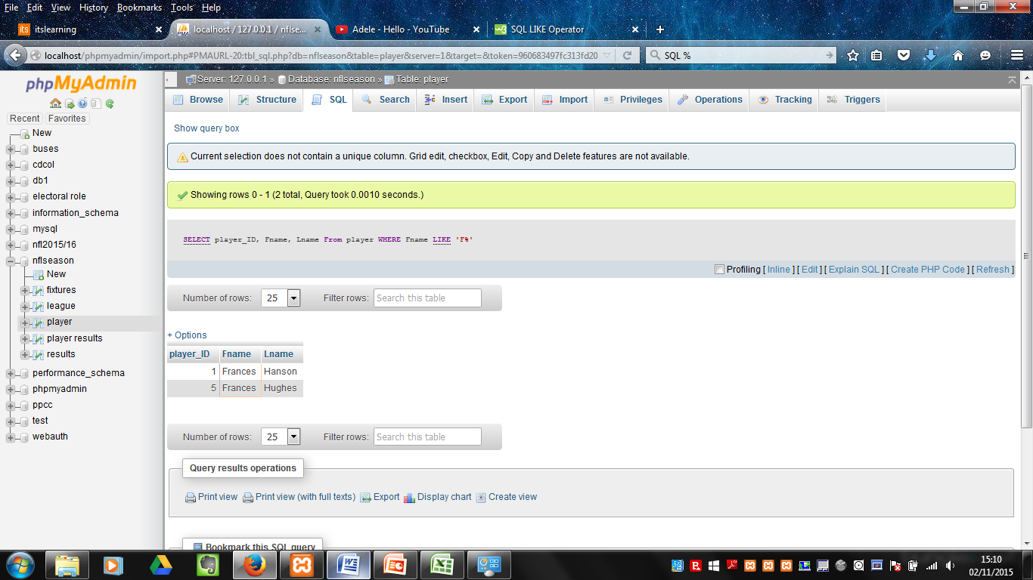
4. First names beginning with ‘F’  
   Display all player ID’s and names who’s last names begin with ‘F’.   
   Information taken from the ‘player’ table.  
   SELECT player_ID, Fname, Lname  
   From player  
   WHERE Fname LIKE ‘F%’;  
   
5. Game Day  
   This will show the Description, Date, Game ID and Fixture ID columns in a separate table.   
   Information taken from the ‘fixtures’ and ‘results’ tables.  
   SELECT DISTINCT GameID, Description, Date  
   FROM fixtures, results  
   Where GameID = Fixture ID  
   ORDER BY Description, Date, Fixture ID  
   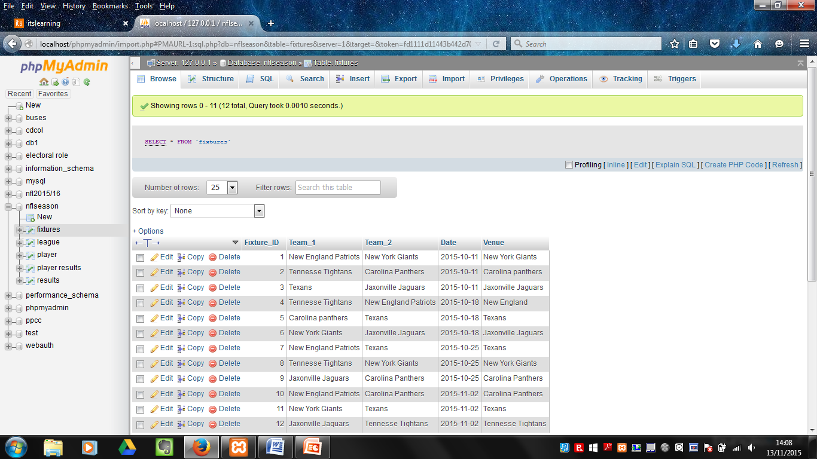
6. 1ST, 2nd and 3rd position   
   Display the top three teams in the league and how many points they have gained throughout the season.   
   Information taken from the ‘league’ table.  
   SELECT Teamname, Team_ID, Position, Points  
   FROM league  
   WHERE position <4  
   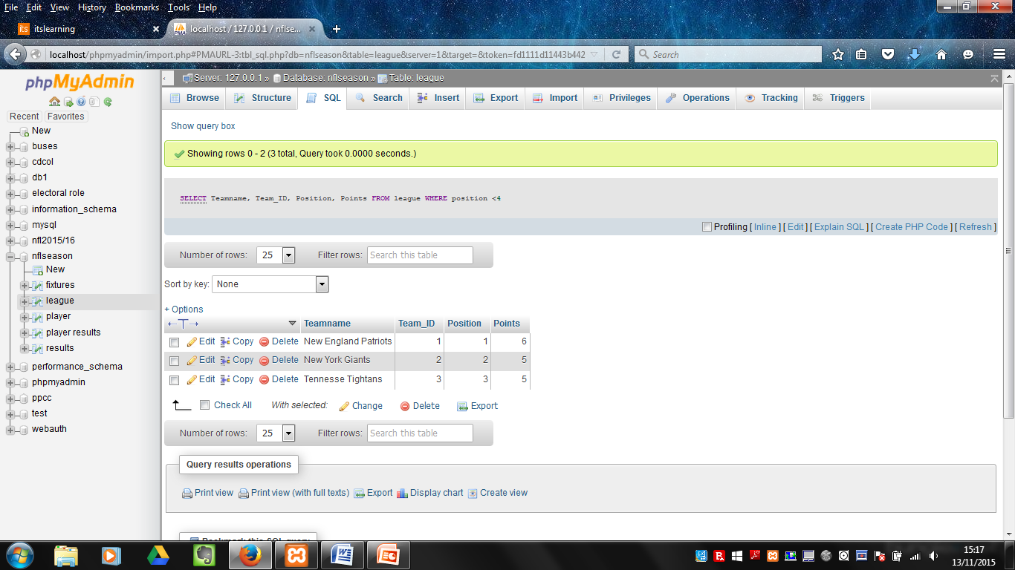
7. 4th, 5th and 6th positions  
   This will display the bottom three teams in league and how many points they have accumulated so far.   
   Information taken from the ‘league’ table.  
   SELECT Teamname, Team_ID, Position, Points  
   FROM league  
   Where position >3  
   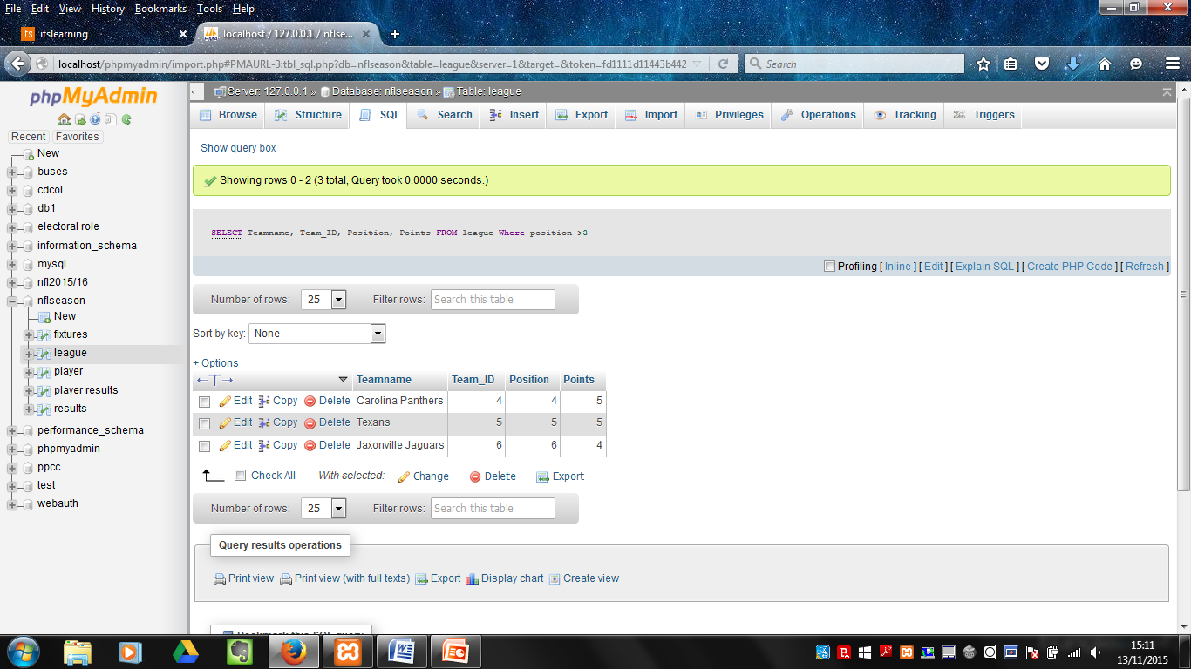
8. Teams and game players  
   This will show the player of the week for each fixture played so far using information taken from the ‘Teams’ and ‘fixtures’ tables.  
   Information taken from the ‘teams’ and ‘fixtures’ tables.  
   Select Team_ID, teamname, Fixture_ID, playerofthegame  
   from teams, fixtures  
   where Team_ID = Fixture_ID  
   order by Team_ID, teamname, playerofthegame  
   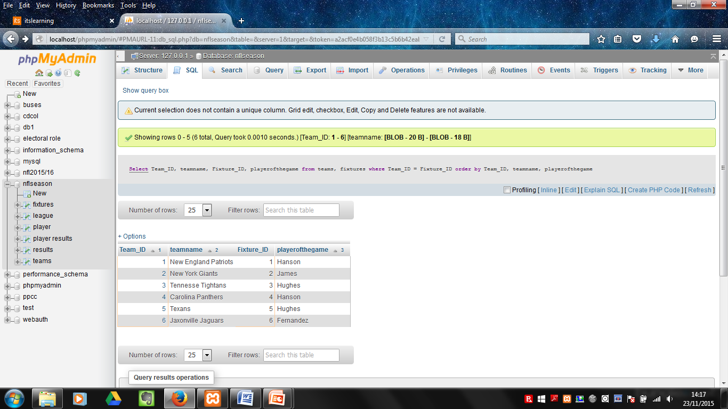

# Testing

|  |  |  |  |  |
| --- | --- | --- | --- | --- |
| Test # | Focus | Action | Expected Result | Pass/ Fail |
| 1 | Team position query | Retrieve all positions in the league table. | New England Patriots 1 New York Giants 2 Tennessee Tightans 3  Carolina Panthers 4  Texans 5 Jaxonville Jaguars 6 | Pass |
| 2 | Player points query | Retrieve all players and the points each player has alongside the team they play for. | Hanson 35 New England Patriots Fernandez 17 New York Giants Alvarez 21 Tennessee Tightans James 27 Carolina Panthers Hughes 18 Texans Davis 31 Jaxonville Jaguars | Pass |
| 3 | Winning teams query | Displays the winning teams and score. | 1. New England 42-17 2. Tennessee 35-13 3. Texans 31-3 | Pass |
| 4 | Displaying the fixtures and venue’s query | Displays the fixtures, dates and venues of each game for the next four weeks of the season. | 12 records expected with all dates listed and venues of each individual game listed for those 12 records. | Pass |
| 5 | Displaying all teams who have 5 points or more query | Displays the teams who have gained 5 points or more in the league. | New England Patriots New York Giants Tennessee Tightans  Carolina Panthers  Texans | Pass |
| 6 | Players with more than 25 points query | Displays all players who have accumulated more than 25 points. | Hanson James Davis | Pass |
| 7 | Teams who have gained 5 points or more or 5 touchdowns query | Displays teams who have gained 5 points or more or 5 touchdowns so far. | New England Patriots New York Giants Tennessee Tightans Carolina Panthers Texans | Pass |
| 8 | Teams with 5 points or more and three touchdowns against query | Displays teams with 5 points or more and have conceded three touchdowns or more. | New England Patriots Tennessee Tightans | Pass |
| 9 | Teams with 4 or more points and 4 or more touchdowns or 4 or less touchdowns against query | Displays teams who have gained 4 or more points and 4 or more touchdowns or have conceded 4 or less touchdowns. | New England Patriots New York Giants Tennessee Tightans Carolina panthers Texans Jaxonville Jaguars | Pass |
| 10 | Texans dates and venues query | Displays all dates that the Texans are playing after 2015/11/10 and all games the Texans are hosting. | Carolina Panthers vs Texans New England Patriots vs Texans New York Giants vs Texans | Pass |
| 11 | Last names beginning with ‘H’ query | Displays all players with the last names beginning with H. | 1. Frances Hanson 5. Frances Hughes | Pass |
| 12 | First names beginning with ‘F’ query | Displays all players whose first names begin with ‘F’. | 1. Frances Hanson 5. Frances Hughes | Pass |
| 13 | Game day query | Displays information taken from the ‘fixtures’ and ‘results’ tables showing the game ID, Description and Date for the current week’s games. | 1. New England Patriots vs New York Giants 2015-10-11 2. Tennessee Tightans vs Carolina Panthers 2015-10-11 3.Texans vs Jaxonville Jaguars 2015-10-11 | Pass |
| 14 | Display 1st, 2nd, and 3rd positions query | Displays the current 1st, 2nd and 3rd teams in the league. | New England Patriots 1 1 6 New York Giants 1 2 5 Tennessee Tightans 1 3 5 | Pass |
| 15 | Display 4th, 5th and 6th positions query | Displays the current 4th, 5th and 6th teams in the league. | Carolina Panthers 4 4 5 Texans 5 5 5 Jaxonville jaguars 6 6 4 | Pass |
| 16 | Teams and game players query | Displays the player of the game and their team from the games played so far. | 1. New England Patriots 1 Hanson 2. New York Giants 2 James  3. Tennessee Tightans 3 Hughes 4. Carolina Panthers 4 Hanson 5. Texans 5 Hughes 6. Jaxonville Jaguars 6 Fernandez | Pass |